Village Missions exists to glorify Jesus Christ by developing spiritually vital country churches in rural North America. We fulfill this aim by placing pastors in small town and rural churches that might otherwise have to close, and in doing so, preserve the Gospel presence in over 220 communities across the United States and Canada.

Our History

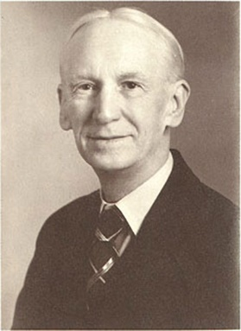
In 1912, an evangelist named Rev. Walter Duff Sr. moved his family from Ireland to the Unites States. As a young man, Walter Duff Jr. joined in his father’s evangelism efforts and went on to pastor his own large church. However, through the prompting of both his father and his sister, Helen Duff Baugh (founder of Stonecroft Ministries), Walter Duff Jr. committed to spend the rest of his life recruiting and sending out of missionaries to country churches without leadership.
Rev. Walter Duff Sr. challenged his son to “send out 100 missionary pastors to rural North America. Thus, on September, 9, 1948, Village Missions was born, a ministry dedicated to sending out missionaries to rural communities across North America with the gospel of Christ. ” During his lifetime, Rev. Duff Jr. directed the sending out of over 600 missionaries. Ever since, Village Missions has served a variety of rural and urban communities across the United States and Canada. God continues to call us to send out dedicated, called, and gifted Village Missionaries to “Preach the Word and love the people.” Today, Village Missions has 230 Village Missionaries currently serving across the North America. Only heaven can measure the impact this ministry has had on individual lives, communities, churches and the world.

Our Values

Qualified Leadership
We value the placement of a full-time, spiritually qualified missionary pastor by invitation of the local people as the primary means of developing spiritually vital country churches.

Supported Leadership
We support our missionary pastors financially and offer District Representatives to help encourage them as well.

Leadership Approach
We value an approach to ministry that proclaims and demonstrates the Gospel of Jesus Christ (Preach the Word and Love the People), and is evangelistic, relational, and involved in community life.

Focused Approach
We value a focused approach of reaching people in rural communities of North America-places without an ongoing demonstration of the gospel.

Long-term Approach
We value a long-term approach that enables rural churches that have reached financial stability to collaborate with us in helping other rural churches, while receiving leadership and encouragement from us.

Christian Character
We value Christian character, specifically integrity, Christ-like love, humility, and faith, in all that we do as a mission and as individuals in our mission. We are committed to the Word of God for all that we are and all that we do.

Spiritually Vital Churches
We value spiritually vital country churches that are making substantial progress in the areas of evangelism, instruction, prayer, worship and fellowship.

CONTACT US
696 E. Ellendale Ave
P.O. Box 197
Dallas, OR 97338-0197
(503) 623-4107
(800) 617-9905

